# Finding out Major resistance based on trend line.

I randomly selected USD/INR monthly chart for period starting 2006 June. At present I am not looking for chart pattern since I need to understand how we will find target (Major Resistance) based on Ascending/ Descending trend line. Please find below analysis & correct me in case I am wrong.

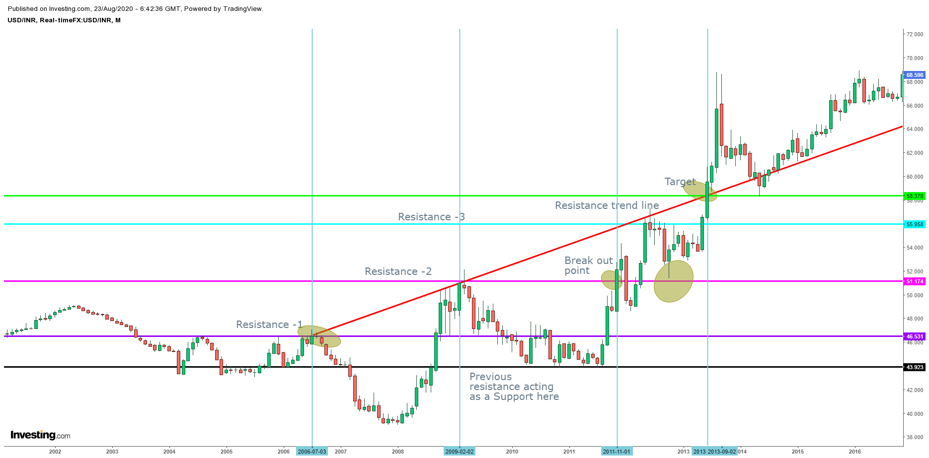

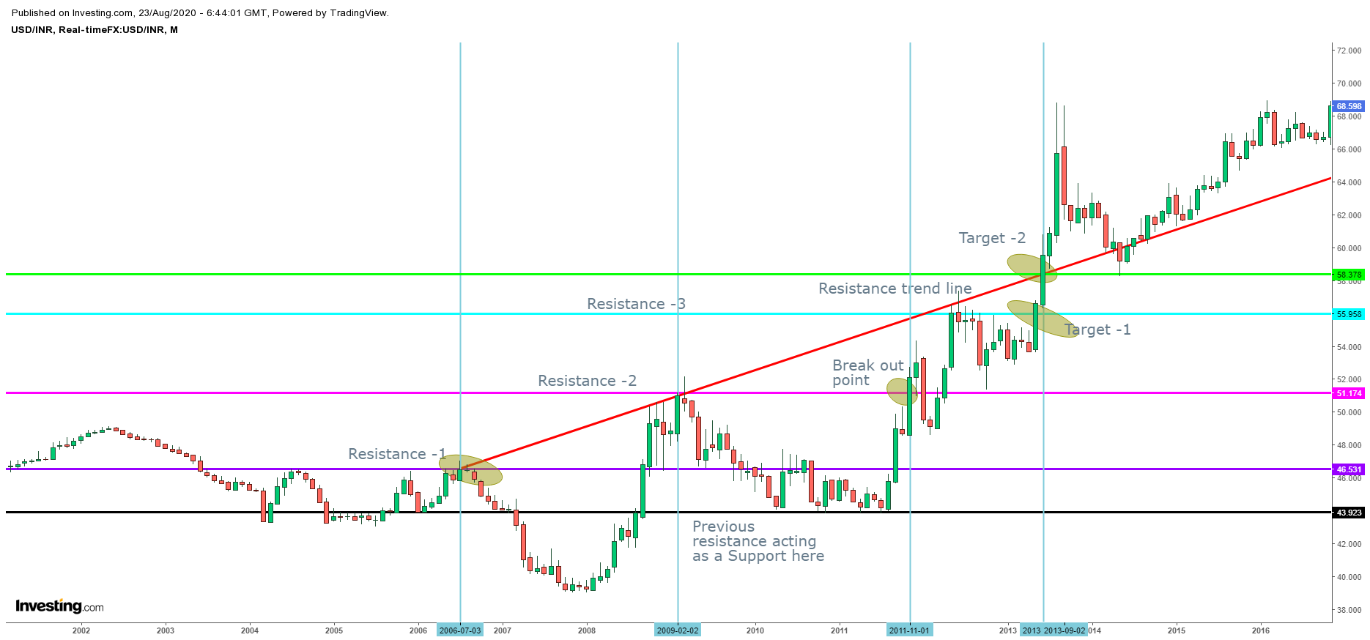

1. Started analysis on 2006-07-03 & Plotted a resistance line -1.
2. Plotted a resistance line – 2 on 2009-02-02 since it is the next high.
3. Now I need an entry point. So I waited for a break out & found it on 2011-11-01. I selected this break out candle as my entry point.
4. Based on MACD & stochastic I decided to Buy.
5. Next I need to find out the target. For that, I plotted a resistance trend line connecting previous highs and waited for the break out. After that , i found a break out on 2013-06-03 and I got the target.
6. If this method is correct, can I conclude Major resistance for bulls exit target is as below,
   1. Where ever my resistance line is broke out, we can consider it as our entry point.
   2. Based on the resistance trend line (regardless of ascending or descending), where ever it broke out, it will be my target.
7. We don’t need to consider Moving Average for now (based on SMM)
8. Also another approach to finding out major resistance is to consider “Previous top or resistance”
   1. For target as “Previous top or resistance”, we consider this only in descending resistance trend line.
   2. Since this scenario is an ascending resistance trend line and there is another resistance line coming before the breakout as mentioned above in (5th point), do we need to consider that point as our first target? (Fig 2). Also next resistance line is marked as “Resistance -3”.